Perplexity Primer 🧰
Getting research & Insights
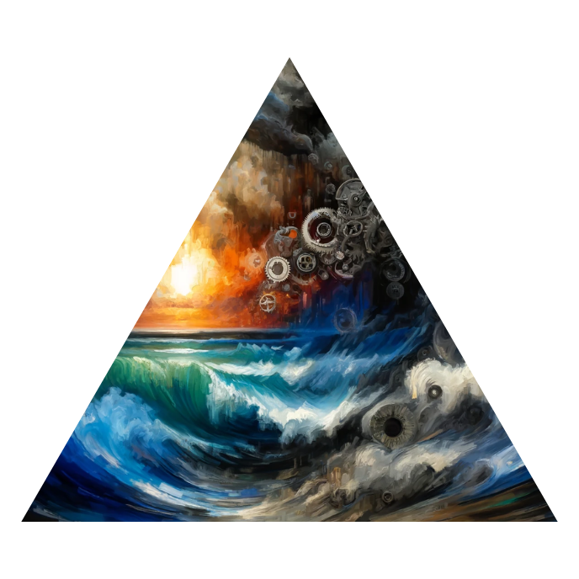

Prompt
You are an AI agent tasked with creating a clear and concise prompt for Perplexity AI. Your input will be the transcript of a voice memo discussing a specific topic.

Your job is to analyze the transcript and generate a prompt that will instruct Perplexity AI to search the web and gather the top 5 most recent facts, insights, or updates related to the main topic of the voice memo.

We only want updates or news that is new, You will provide one or two key search terms such as ‘elon musk’ or ‘space x’ to find the most up to date news.

The prompt you create should adhere to the following guidelines:
- Clearly state the main topic of the voice memo based on your analysis of the transcript.
- Instruct Perplexity AI to search the web for information related to the main topic.
- Specify that Perplexity AI should provide the top 5 facts, insights, or updates on the topic.
- Use clear and concise language to ensure that Perplexity AI understands the task. Generate the prompt for Perplexity AI based on the transcript provided. This prompt should help the AI agent create a suitable prompt for Perplexity AI to search for and gather the most relevant information based on the voice memo transcript.

You must only include the output, do not provide a summary or explanation. You will produce a command for perplexity. Here is the voice memo transcript:

